**SBA_Assesment_9**

**How to deploy spring boot application in aws**

Step1:

Create a jar file for your spring boot application

1. Start Eclipse and navigate to your workspace.
2. In Package Explorer, left-click on the project you want to export.
3. Right-click on the same project and select Export
4. When the Export dialog box pops up, expand Java and click on JAR file. ...
5. The JAR Export dialog will pop up. ...
6. Click Finish.

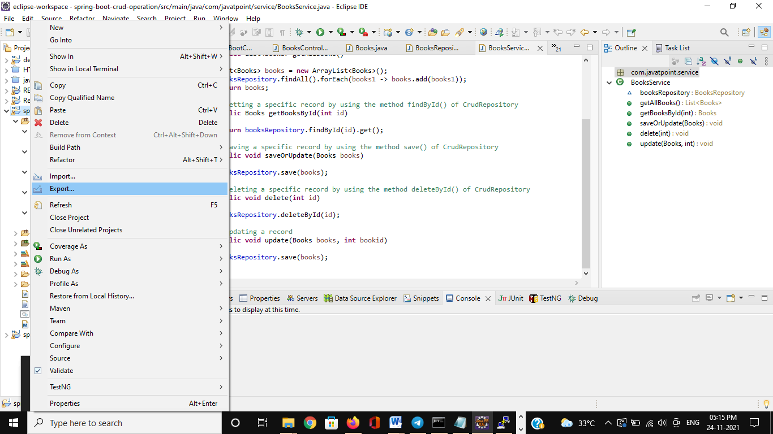

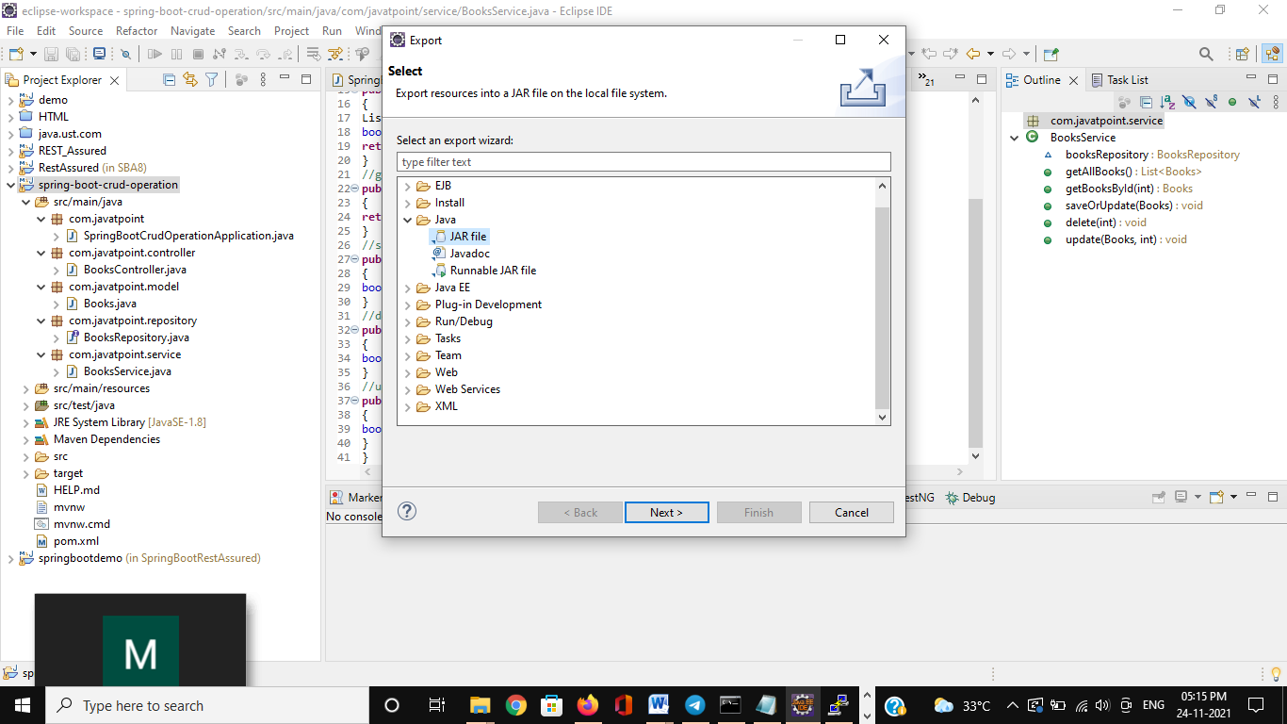

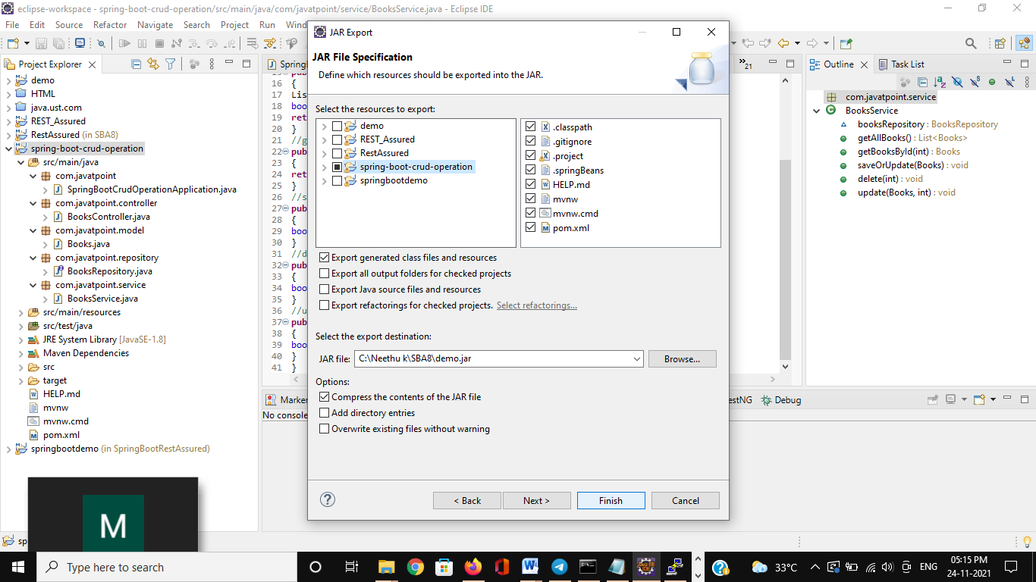

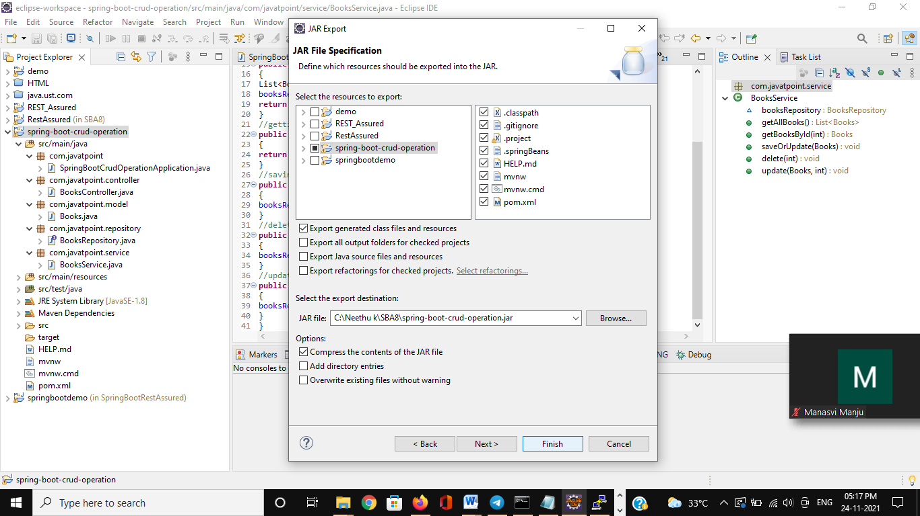

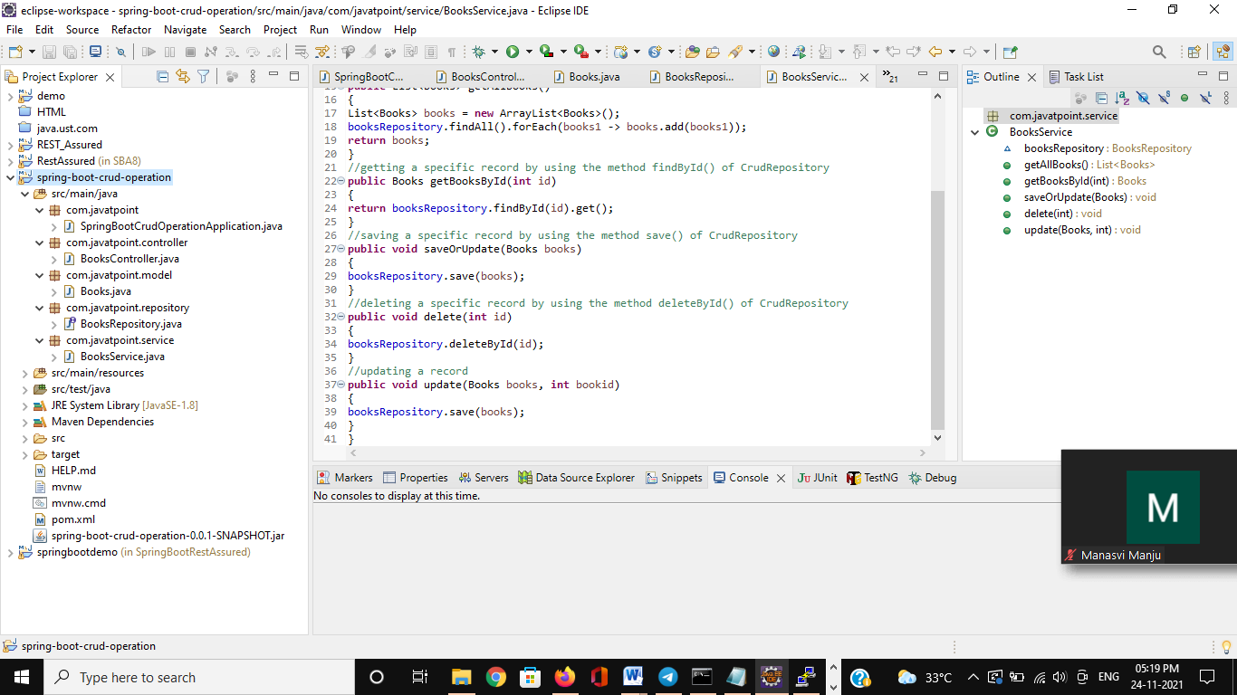

Step 2:

Create a bucket in aws console and save jar file inside that bucket

1. Go to sevices in the top and select S3.
2. Create a bucket inside that.
3. Upload your jar file into the bucket.

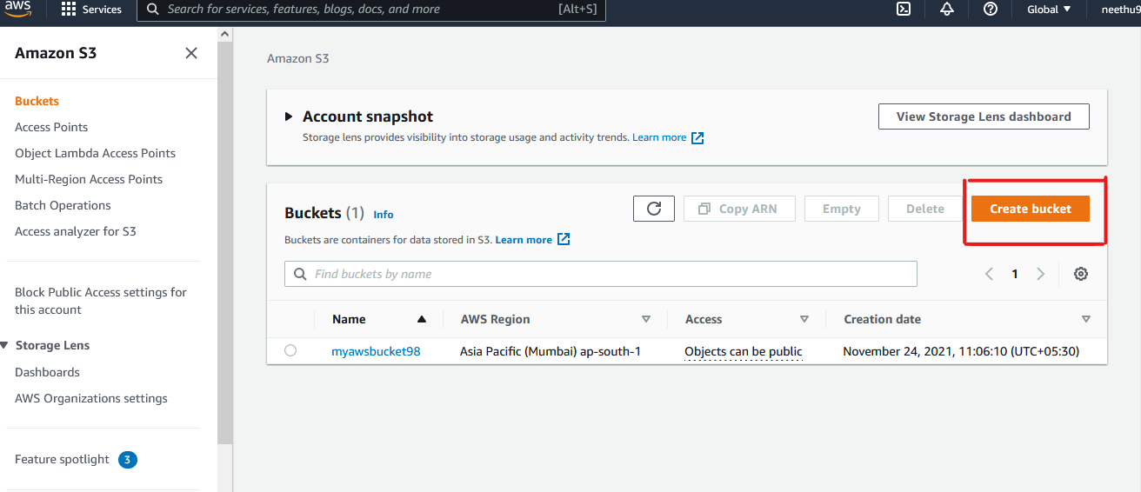

Step 3 : launching instance

1. Go to services 🡪 click on EC2 🡪 launch instance
2. Choose AMI 🡪 Ubuntu
3. Click next configure instance details
4. Click next add storage
5. Click next add tags
6. Click next configure security groups
7. Add rule in the page 🡪 give port no as 8080 and source as anywhere
8. Click on review and launch🡪 click launch on next page

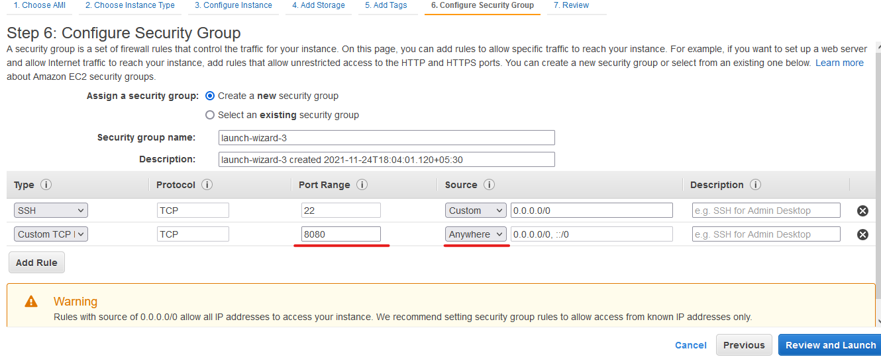

1. Select create a new key pair🡪choose key type as shown 🡪give a key name 🡪 download the key pair🡪 launch

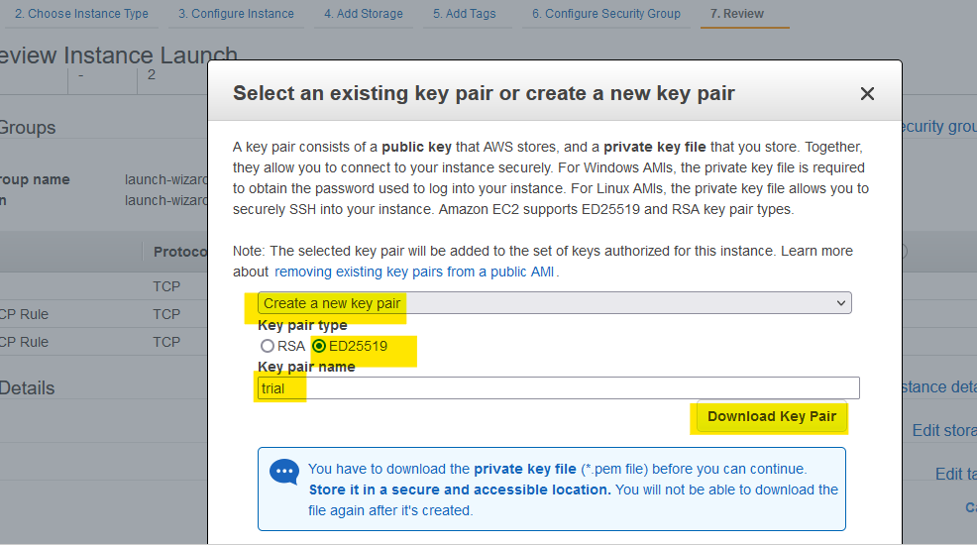

1. Name your instance

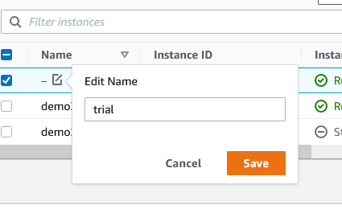

Step 4:

Connect instance

1. Click on the instance which you want to connect 🡪 click connect on the top

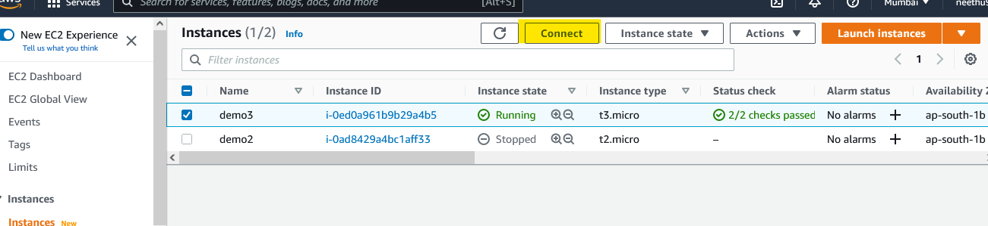

1. Copy the DNS

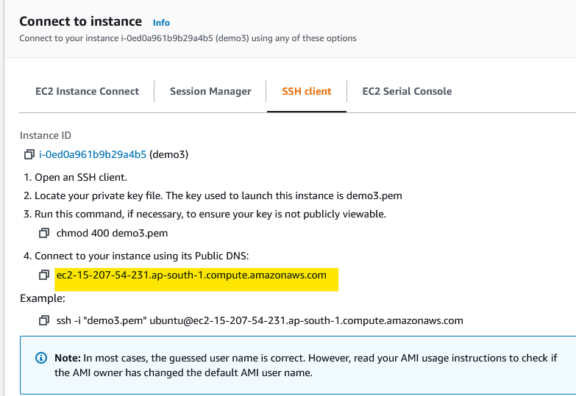

Step 5:

Download PuTTY from [www.putty.org](http://www.putty.org)

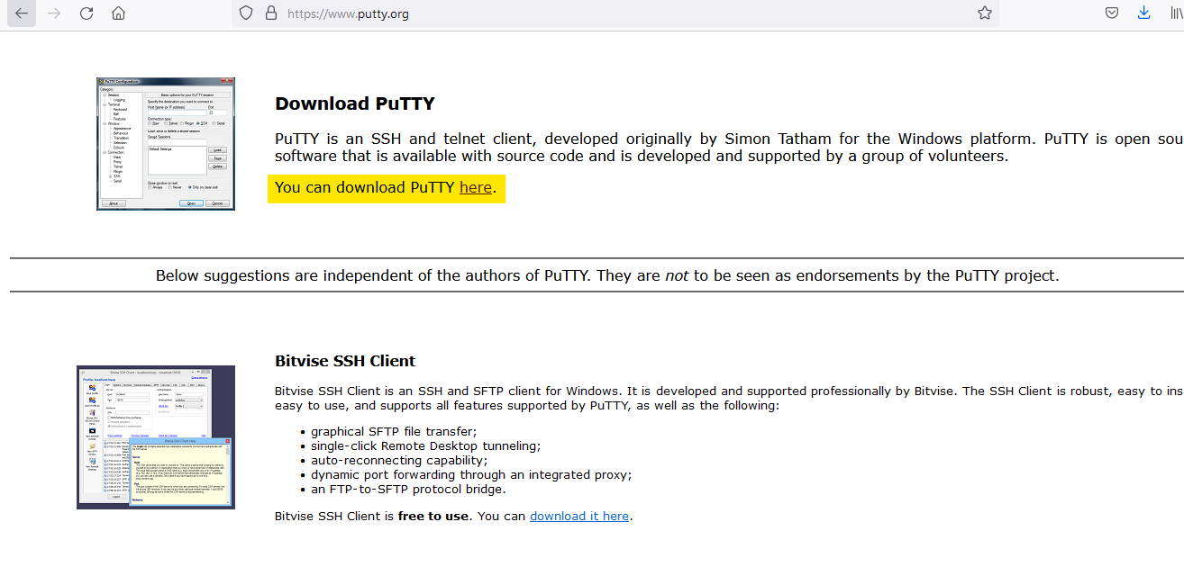

Step 6:

1. open the puttygen from program files
2. select load

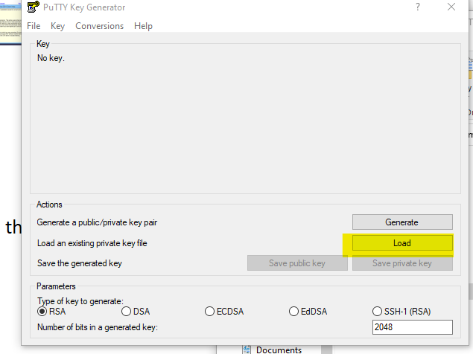

1. select the pem file you downloaded while launching instance (make sure you select all files)
2. open the pem file

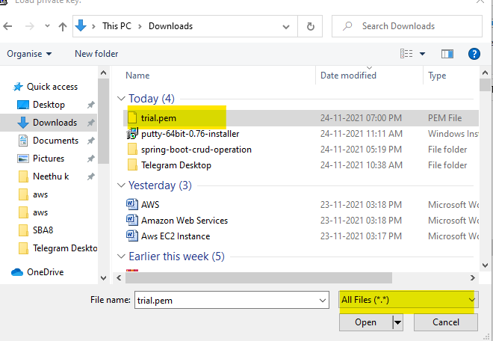

1. click on save private key

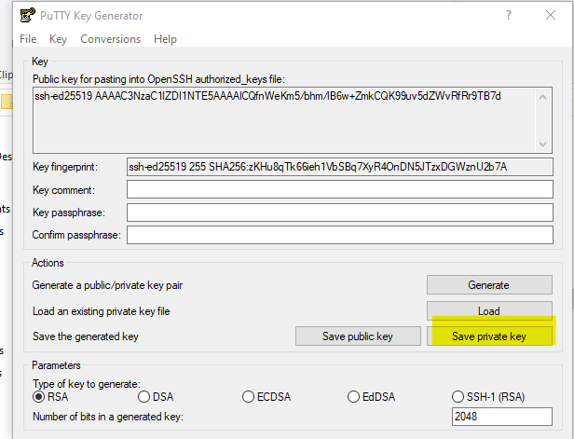

Step 7:

1. open the putty from program files

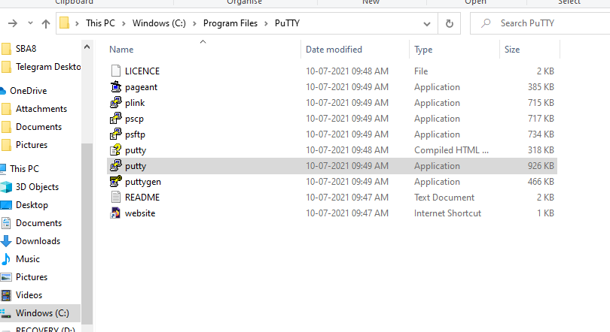

1. copy paste host name (paste the DNS as host name)

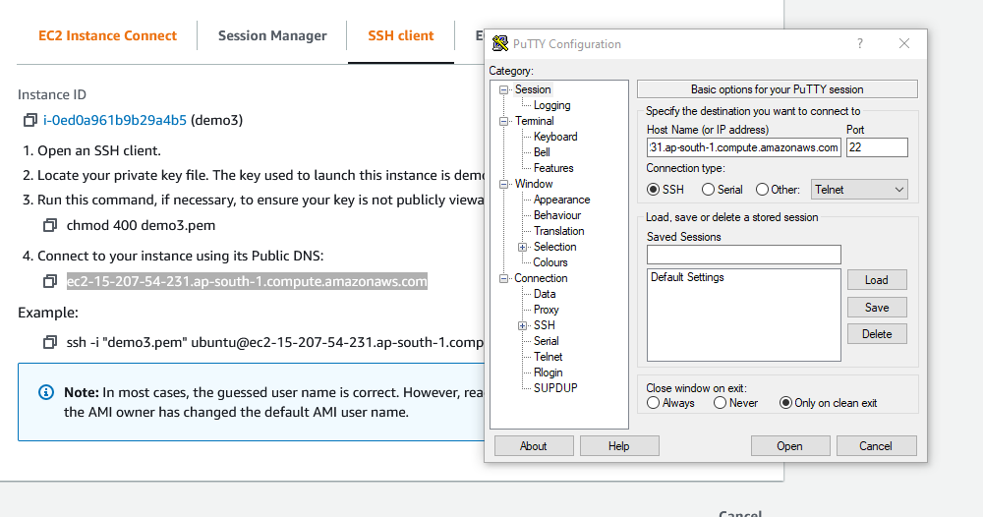

1. select data 🡪 give user name as ubuntu(as in your eg)

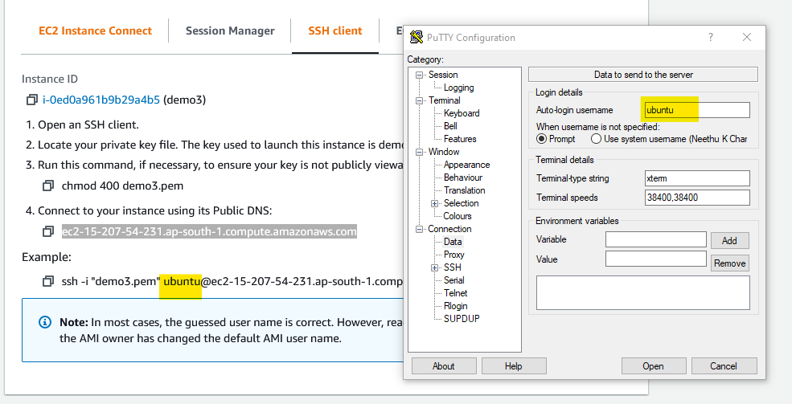

1. click on SSH🡪 select auth🡪 browse our putty private key🡪 click open

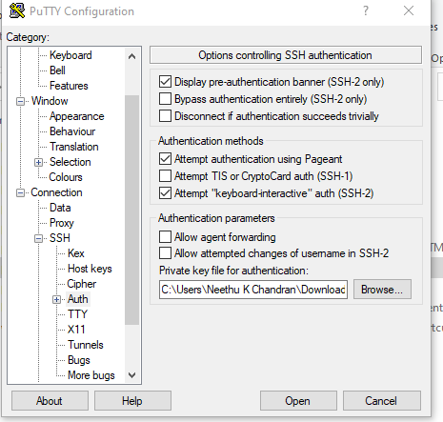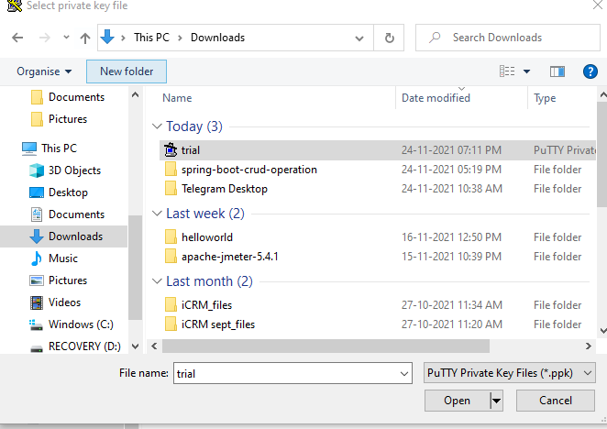

1. your terminal will be open

Step 8:

1. type sudo –i in the terminal

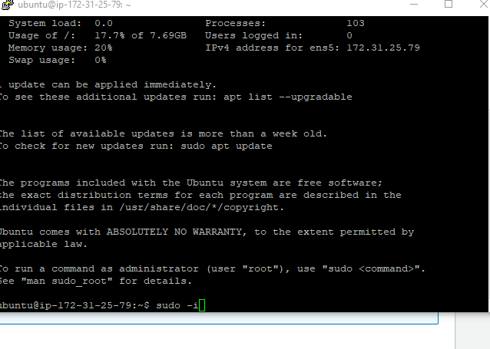

1. check your java version 🡪 type java –version
2. if java version not came 🡪 install java 🡪type “sudo apt update” in terminal
3. Then type “sudo apt-get install default-jre”.(java installed)
4. Just check for java version then (“java –version”)
5. Type wget <https://myawsbucket98.s3.ap-south-1.amazonaws.com/jarfile/spring-boot-crud-operation-0.0.1-SNAPSHOT.jar> (object url)in terminal

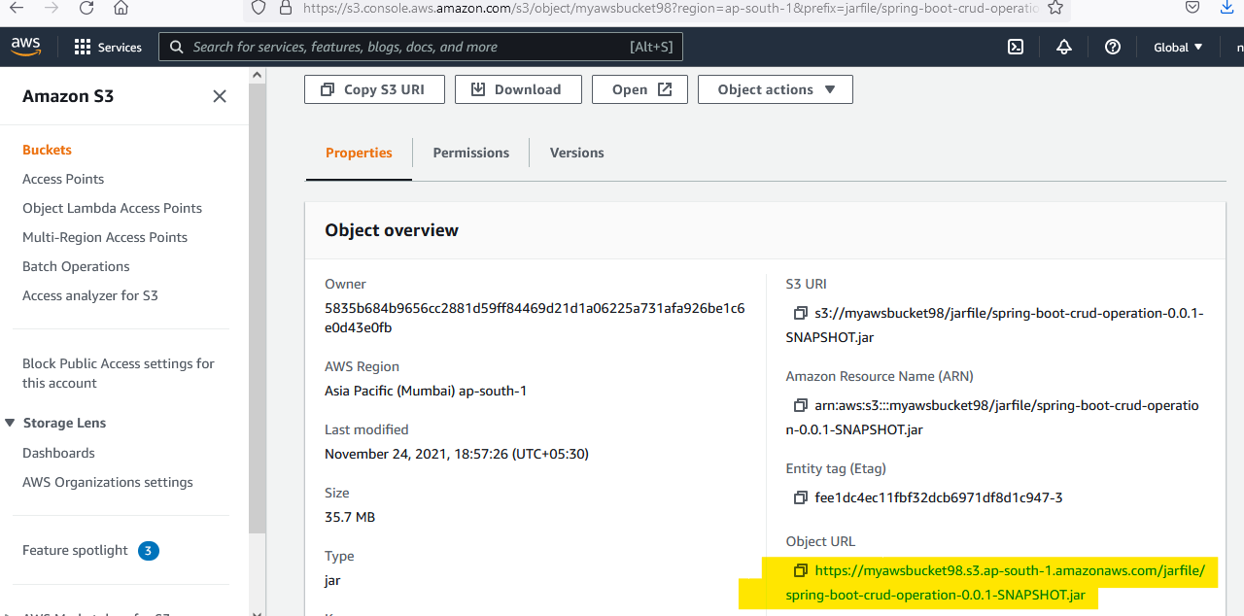

1. Then type java –jar spring-boot-crud-operation-0.0.1-SNAPSHOT.jar (jar file name).

